MULTICULTURAL COMMUNITIES’ LEADERSHIP IN ACTION PROGRAM 2022: FACILITATION TOOLKIT

INTRODUCTION
As part of the Multicultural Communities Leadership in Action Program 2022 Women’s Session you will be given the opportunity to practice and hone your facilitation skills in a culturally safe and context specific way. This guide is designed to give you an overview of facilitation and some tips and tricks you can use to facilitate workshops or meetings in your role.

All learning happens inside the learners’ heads. Our role as facilitators is to set up the internal process that will help the information stick.

Role of a facilitator:

o Keep the group ‘on track’
o Identifying and linking common themes
o Clarifying confusing statements
o Summarising and organising ideas
o Decision identification
o Testing for agreement
o Facilitating conflict resolution
o Establishing and maintaining safe and comfortable environment

How does a facilitator do this?

- Ensuring people hear each other
- Equalising participation
- Pacing the session
- Negotiating time adjustments
o Identifying and acknowledging feelings
o Identifying, naming and resolving conflict
o Soliciting feedback

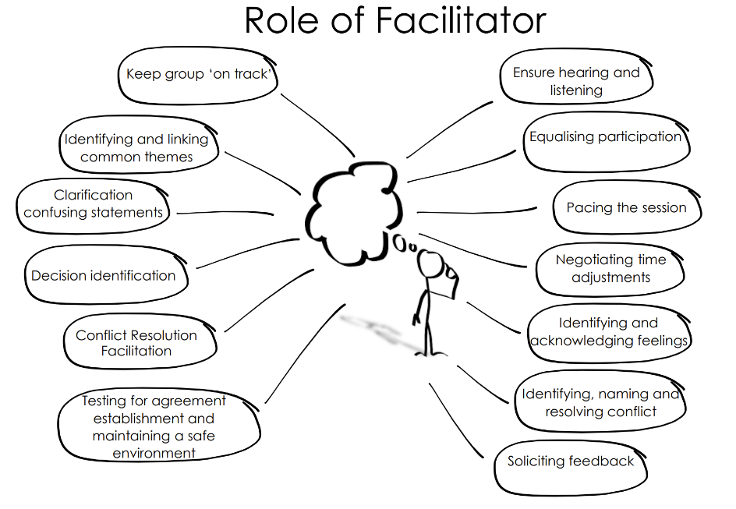

Three golden rules

- Prepare
Successful workshops require preparation. Sit down with your partner and allocate different parts, how will they flow on from one another? What are the most important points? Can you use different mediums? Draw a picture? Show a 2-minute video? Use any props?

- Start with the Why – tell them why they want this information before you say what you are going to do. People don’t buy what you do, but why you do it.
“My name is X and I am here today to teach you about the volunteering guidelines”
vs
“We know that volunteers are the heart and soul of community organisations. This workshop today explains how to recruit and retain volunteers so your organisation can have an even bigger impact.”
“I am here today to teach you about the volunteering guidelines”

- Keep it simple
It is not about presenting the MOST content. It is presenting the MOST IMPORTANT content. One of the most common mistakes first time facilitators make is trying to cram too much in and over-control the session. If the people in your organisation are fascinated by a certain aspect of volunteer management, – spend more time on that. Don’t cut a really good discussion short just to stick to the time limit. Also, factor in the multicultural breadth of your group and ascertain appropriate ways of drawing in those who may need more encouragement to participate or, be politely managed tonot overshare.

Facilitation Tricks of the Trade
Skill | Definition
Sitting with hotspots | A ‘hotspot’ occurs in a group when strong feelings are expressed, when conflict erupts, or people get upset or angry.  Common mistakes facilitators make with hotspots:  Rushing in to rescue a person  Offering solutions  What you should do:  Hold the space  This allows people to express their feelings, to be heard and validated and move on.  This is tricky and takes practice. We need to support people who are saying what is difficult to say, but we need to give equal support to those who find the things difficult to hear.
Noticing and Wondering | We like to think of this as if you are holding a mirror up to the group/individual so they can become aware of their unconscious attitudes. Also be aware of cultural traits you are familiar with that may impact participation of others  There are two scenarios where this skill really comes in handy:  - When we are absorbed in personal issues and not always aware of what is going on.  - When there is an elephant in the room that needs to be brought up before people can relax into the session.  Good facilitators pick up on what is going on and feed it back to us in a non-judgemental way.  “I noticed X,Y and Z, I wonder if A, B and C might be going on?”  “I notice that people seem to be talking all at once”  “Your foot is tapping Frank, what’s that about”  “The group seems a bit flat today”  “Helen, I’ve heard you say “It’s too hard” several times during this discussion, what does that mean for you?”
Validating & Normalising | t can be powerful to have what we are feeling/experiencing affirmed as normal.  “That makes sense, no wonder you were upset, anyone would have been”  “It’s normal to feel on edge when you are discussing issues which are really important to you”  What not to do: Don’t hijack their story  “Oh that’s terrible, the same thing happened to me the other day.…”  The skill is to validate the emotion rather than the opinion or content.

COMMON MISTAKES FACILITATORS MAKE & HOW TO AVOID THEM

Skill | Common mistakes | Solution
Asking questions | Asking questions that are too complex: “explain the difference between product liability insurance and public liability insurance in relation to what they protect”  Or too simple:  “Who knows what the word protect means?” | Asking complex questions will alienate the audience and make them feel inadequate.  Asking simple questions will be patronising.  You need to find the sweet spot in between.
Sharing the airspace | Talking and over-explaining when feeling nervous.  Focusing solely on the content and not remembering to ask questions. | Think of a question like a volleyball. You serve the ball, and it bounces from person to person and then when it hits the ground you serve up another question.  There are times when you must give people information. But if you can guide people to discover the answers themselves, they are much more likely to remember the content.
Focus on the outcome | Focusing on the content. Brainstorming all the content and creating a PowerPoint with all the information neatly organised. | Focus on the outcomes and learning experience.  Ask: at the end of this workshop, what do I want the learners to be able to do, out in the real world?  Then create tasks to assess how ready the participants are to achieve the outcomes.
Validating contributions | Ignoring answers, you decide are wrong and only paying attention to ‘good answers’.  e.g only writing the contributions you like on the board and rephrasing the ones you don’t. | Everyone’s contributions are equal regardless of where or not they are ‘right.’  Find similarities between the ‘wrong’ answer and the right answer.  “Sarah is right in saying X because of Y”
Keep the process to yourself | Telling participants what they are missing out on.  “I had this really good video to show you, but I forgot to download it”  “We are behind in time, so I am going to cut this next session short” | Telling participants about the inside workings of a session is distracting – it stops them from focusing on the key messages.  The participants don’t know they are missing out on anything unless you admit it to them.
Simplifying | Information overload: Delivering all the information in one go. | People prefer to learn in chunks of 3-7 bits of information. Break information down. Point out patterns. Reduce to key points. Summarise.  Simplify – Teach in the way you wish the concepts had been explained to you.  Continually assess understanding. One way to do this is to ask a participant to explain back to you a concept in their own words.
Working without notes | Using the discussion guide as a script.  Having your head buried in the script instead of in the group. | Use the script as a safety blanket but nothing more.  Set it on the desk and glance at it only long enough to see what the next topic is.
Flexibility | Being inflexible with your questions.  “Do any of you have a problem with volunteer management? No? ……. Well…. If you did have a problem what would it be? “ | Rephrase the question making relevant adjustments.  “That’s really great that you don’t have a problem. Volunteer management is an issue in lots of community organisations, why do you think organisations struggle to engage and retain volunteers?”

Notes:

